- Membership
- Events
- Global
- Specifications
- Login
- Initiatives »
- Developers »
- Certified Products »
- Learning Impact »
- Leadership »
- Search

Introduction to Competencies and Academic Standards Exchange™ (CASE™)

What is CASE?
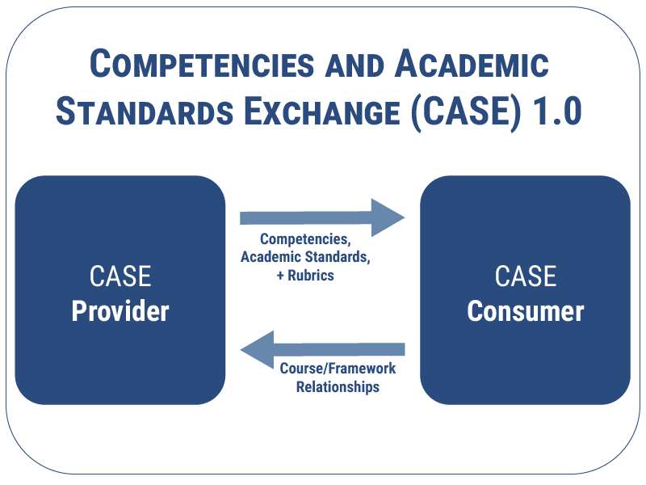The Competencies and Academic Standards Exchange (CASE) specification defines how systems exchange and manage information about learning standards and/or competencies in a consistent and referenceable way. The key aim is to replace the current ways of documenting and referencing learning standards and competencies, which are typically published as a PDF or HTML documents or spreadsheets intended to be read by humans, with one which is also machine readable syntactically and semantically.

CASE includes the following key attributes:
- The original competencies or academic standards (document)
- Machine-readable statements of what the learner will know and be able to do (items)
- Explanations of relationships between standard sets and/or among individual standards or courses where applicable (associations)
- Guides listing specific criteria for grading or scoring academic papers, projects, or tests (rubrics)

What education scenarios are supported by the specification?
Currently learning standards and competencies are being interpreted as they are translated from static PDF documents into machine-readable formats. The authorizing body for a set of standards is often not involved nor are the identifiers for a given academic standard or competency the same across different platforms. Thus data transmitted from one system to the other can’t be easily aggregated or aligned. With CASE, education competencies are in the same format using a universal identifier, making aggregation of data more reliable and efficient. This specification also support the exchange of competency-based data and course relationships between systems.

Digital content providers wishing to align content to multiple standard sets must make their own decisions about the relationships among the standard sets in order to do this. With CASE, the learning standards authorizing body has the capability to make available indicators as to how their learning standards align to other standard sets.

In addition, rubrics and outcomes data can be transmitted between platforms and tools. A certificate or diploma granting body establishing performance criteria for an end of program review can now make that information available in a machine-readable format to be consumed by the learning platform and other digital tools.

For more information, see Real-World Scenarios and What is CASE? (presentation)

Who benefits?
Suppliers, academic standards and competencies authorizing bodies, such as state departments of education, and institutions benefit from a common way to reference learning standards and competencies.

What problems are being solved?
Educators have a more reliable way to ensure digital content is properly aligned to learning standards. Systems that are traditionally course-based can now have access to related competencies that are taught in a course, module and topic.

What are the specification features?
Association and transmission of learning standards/competencies and their internal relationships (parent/child)
Association and transmission of rubrics including criteria and performance levels
Ability to define relationships between and among autonomous learning standard sets.

What is the normal process flow?
CASE defines two roles, a Provider and a Consumer. Learning Standards and Competency authorizing bodies or institutions or their proxy can create and make available a standard set or sets for import into a consumer system, such as an learning management system or formative assessment system.

Does this update or replace one or more existing specs?
This is the initial version of the standard specification.

What additional information is important about CASE 1.0?
When adopting digital content, learning platforms or other systems offering learning standards-alignment as a part of their features, it is very important to understand whether the system supports the interoperability and assurance of the possibility of common alignment afforded by CASE.

- About IMS
- Initiatives
- Leadership Activities
- Initiative Sponsors
- Collaborations and Affiliations
- News
- Leadership Institute
- Learning Impact Awards
- Learning Impact Blog
- Leadership Awards
- William H. (Bill) Graves Leadership Award
- Technical Activities
- Product Directory
- Download Standards
- Technical Resources Search
- Forums
- Members
- Contact Us
- Join the IMS Public Community
- Career Opportunities
This page contains trademarks of the IMS Global Learning Consortium including the IMS Logos, Learning Tools Interoperability® (LTI®), Accessible Portable Item Protocol® (APIP®), Question and Test Interoperability® (QTI®), Common Cartridge® (CC®), AccessForAll™, OneRoster®, Caliper Analytics®,SensorAPI™ and Competencies and Academic Standards Exchange™ (CASE™). For more information on the IMS trademark usage policy see trademark policy page
© 2001-2017 IMS Global Learning Consortium Inc. All Rights Reserved. Privacy Policy

