Implementing Digital Learning at _______ University

(Statement about why digital learning at your university is important.)

(Statement about how Canvas facilitates digital learning.)

(Statement about attached checklists guiding the institution vision towards digital learning.)

(Statement addressing where additional professional development and resources need to be dedicated to align with digital learning.)

(Statement about how the checklists align to SAMR model of technology integration.)

Bloom’s Taxonomy & SAMR

Description

With both Bloom’s Taxonomy and the SAMR Model of Technology Integration, the complexity is increased at each level. By linking the two together, we can now see how tasks are created that deeply embed the technology and enhance its use, rather than using the technology just because it’s there. This link allows us to see more clearly how Canvas can be used to reach areas of our students learning that were previously inconceivable.

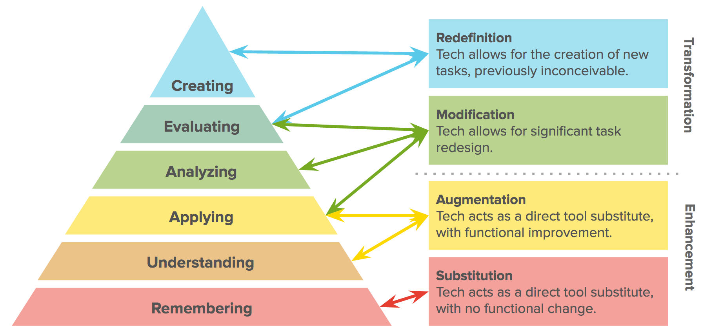

University Leaders
Digital Learning with Canvas Checklist

Component 1 - Vision and Strategy
Creates and communicates digital learning vision to all stakeholders
Substitution
- Uses Canvas Global Announcements to communicate vision and strategy to faculty and students
Augmentation
- Uses Canvas Calendar to notify users of timelines and important training dates
Modification
- Uses a faculty resources course and models Canvas usage for faculty
Redefinition
- Uses Canvas Analytics to help identify leaders and super users
- Empowers super users by giving them a role with professional development
Component 2 - Personal Growth
Organizes professional development in digital learning environment
Substitution
- Uses Canvas Announcements to communicate professional development to faculty
Augmentation
- Models Canvas best practices by using Canvas courses for all faculty training
Modification
- Organizes all digital learning professional development in a Canvas Course
Redefinition
- Organizes professional learning communities in Canvas Courses

Component 3 - Leadership
Models digital learning to all stakeholders
Substitution
- Provides faculty and students with information through Canvas
Augmentation
- Uses Canvas Global Announcements to push information to both faculty and students
Modification
- Elicits feedback from faculty and students in Canvas through the use of Canvas quizzes and surveys
Redefinition
- Flips department meetings using a Canvas Course
Component 4 - Community
Provides a digital learning community for all stakeholders
Substitution
- Uses Canvas Global Announcements to communicate vision and strategy to faculty and students
Augmentation
- Provides community public Canvas course with information about university events and important dates
Modification
- Shares challenges, solutions, and ideas in the Canvas Community
Redefinition
- Uses Canvas Surveys to determine next steps in Canvas Usage

Faculty
Digital Learning with Canvas Checklist

Component 1 - Assessment and Data
Assesses students in digital learning environment
Substitution
- Uses Canvas Quizzes to give formative and summative assessments to students
Augmentation
- Utilizes Canvas Question Banks to create unit specific sets of questions
- Differentiates Canvas Assignment due dates
Modification
- Attaches Canvas Rubrics to formative and summative assessments
Redefinition
- Assesses students using Canvas Outcomes
- Modifies student learning pathways using Canvas Mastery Paths
- Uses Canvas Learning Mastery Gradebook to improve instruction and target remediation
Component 2 - Collaborative Digital Environment
Incorporates collaborative digital learning environment
Substitution
- Creates and assigns groups in Canvas
Augmentation
- Facilitates Group discussions in Canvas
- Assigns Peer reviews in Canvas
Modification
- Differentiates assignments based on groups
- Facilitates student group page in Canvas for collaboration
- Uses Canvas Conferences to allow groups to communicate outside the classroom
Redefinition
- Uses Office 365 or Google Drive integrations to allow students to collaborate in real time
- Connects students to global community with Twitter or another LTI tool (educreations, Portfolium)
Component 3 - Community
Connects students to the local and global community through digital learning
Substitution
- Uses external links in Canvas to link students to outside resources
Augmentation
- Links to external discussion boards and community pages in Canvas
Modification
- Embeds external Video Conference tools to connect to learners around the world
Redefinition
- Connects to global community with Twitter or other LTI Integrations (educreations, Portfolium)
Component 4 - Feedback
Provides quality feedback to students in digital learning environment
Substitution
- Uses Canvas Gradebook to give grades to students
Augmentation
- Provides written feedback to students in Canvas SpeedGrader
Modification
- Uses video/audio feedback option in Canvas SpeedGrader
Redefinition
- Utilizes Canvas tools like Scheduler and Conferences to give student feedback
Component 5 - Digital Content and Instruction
Teachers will know and use appropriate digital tools and resources for instruction.
Substitution
- Uses Canvas Content Pages
- Links students to external websites
Augmentation
- Uses Canvas Assignments, Discussions, and Quizzes
Modification
- Uses Canvas Arc video tool
- Uses LTI tools in Canvas to bring external apps into their Canvas space
Redefinition
- Provides students with a wide range of submission options when creating and assigning Assignments in Canvas
- Uses Canvas Mastery Paths to provide learning pathways for students
Component 6 - Digital Citizenship
Models digital citizenship to students
Substitution
- Coaches students on discussion prompt responses in Canvas
Augmentation
- Participates in Canvas discussions with students
- Communicates with students via Canvas mail or feedback in SpeedGrader
Modification
- Holds Canvas video conferences with students using Bigbluebutton
Redefinition
- Uses Canvas LTI tools to connect students with people outside the classroom in a meaningful, legal, and safe way
Component 7 - Accessibility
Instructor and content are available 24/7
Substitution
- Posts syllabus and disclosures in Canvas to ensure all students are aware of procedures and availability of both the content and instructor
Augmentation
- Uses Canvas Inbox to email students
Modification
- Uses Canvas Calendar to make office hours visible to students
- Uses Canvas Scheduler
- Uses Canvas Notifications Settings to ensure communication
Redefinition
- Uses Canvas conferences to hold virtual office hours

